Topic Modelling
- Topic modelling in NLP, which assigns topic to a given corpus based on the words present.

- Topic modelling is important, because in this world full of data it has become increasingly important to categories the documents.
- Topics can be thought of as keywords which can describe a document, for example, for a topic sports the words that come to our mind our volleyball, basketball, tennis, cricket etc.
- A topic model is a model, which can automatically detect topics based on the words appearing in a document.
- It is important to note that topic modelling is different to topic classification.
  - Topic classification is a supervised learning while topic modelling is a unsupervised learning algorithm.

Latent Dirichlet Allocation
LDA, short for Latent Dirichlet Allocation is a technique used for topic modelling.
- Latent means hidden, something that is yet to be found.
- Dirichlet indicates that the model assumes that the topics in the documents and the words in those topics follow a Dirichlet distribution.
- Allocation means to giving something, which in this case are topics.

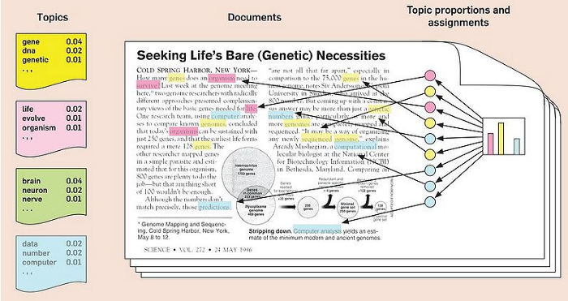

The general steps in the LDA are as follows:
Hyperparameters in LDA:
There are three hyperparameters in LDA
- α hyperparameter controls the number of topic expected in the document.
- β hyperparameter controls the distribution of words per topic in the document, and
- K defines how many topics we need to extract.

LDA
LDA is used to classify text in a document to a particular topic.
It builds a topic per document model and words per topic model, modelled as Dirichlet distributions.
- Each document is modelled as a multinomial distribution of topics and each topic is modelled as a multinomial distribution of words.
- LDA assumes that every chunk of text we feed into it will contain words that are somehow related. Therefore, choosing the right corpus of data is crucial.
- It also assumes documents are produced from a mixture of topics. Those topics then generate words based on their probability distribution.

We have the following 3 documents:
- Doc 1: "I like to eat broccoli and bananas."
- Doc 2: "I ate a banana and spinach smoothie."
- Doc 3: "Cherries are my favorite fruit."
Vocabulary
From the documents, extract a vocabulary (unique words):
[broccoli, bananas, eat, like, to, and, I, ate, a, spinach, smoothie, cherries, are, my, favorite, fruit]
This gives us a vocabulary size V=16

Input Matrix (Document-Word Matrix)
Create a document-word matrix D * V, here D is the number of documents.
 | broccoli | bananas | eat | like | to | and | I | ate | a | spinach | smoothie | cherries | are | my | favorite | fruit
Doc 1 | 1 | 1 | 1 | 1 | 1 | 1 | 1 | 0 | 0 | 0 | 0 | 0 | 0 | 0 | 0 | 0
Doc 2 | 0 | 1 | 0 | 0 | 0 | 1 | 1 | 1 | 1 | 1 | 1 | 0 | 0 | 0 | 0 | 0
Doc 3 | 0 | 0 | 0 | 0 | 0 | 0 | 0 | 0 | 0 | 0 | 0 | 1 | 1 | 1 | 1 | 1

Step 1: Assign Initial Topics
Assume we want 2 topics K=2.
Randomly assign each word in each document to one of the two topics.
For example:
- Topic 1: Related to food/recipes.
- Topic 2: Related to favorites/fruits.

Initial topic assignments might look like this:

Word | Doc 1 Topic | Doc 2 Topic | Doc 3 Topic
broccoli | 1 | - | -
bananas | 1 | 1 | -
eat | 1 | - | -
like | 1 | - | -
to | 1 | - | -
and | 1 | 1 | -
I | 1 | 1 | -
ate | - | 1 | -
a | - | 1 | -
spinach | - | 1 | -
smoothie | - | 1 | -
cherries | - | - | 2
are | - | - | 2
my | - | - | 2
favorite | - | - | 2
fruit | - | - | 2

Step 2: Count Words by Topic
Count the occurrences of words for each topic in each document.
Here's an example of the counts for Topic 1 and Topic 2.
 | Topic 1 Count | Topic 2 Count
broccoli | 1 | 0
bananas | 2 | 0
eat | 1 | 0
like | 1 | 0
to | 1 | 0
and | 2 | 0
I | 2 | 0
ate | 1 | 0
a | 1 | 0
spinach | 1 | 0
smoothie | 1 | 0
cherries | 0 | 1
are | 0 | 1
my | 0 | 1
favorite | 0 | 1
fruit | 0 | 1

Step 3: Update Topic Probabilities
For each word, update its topic assignment based on the probability distribution:

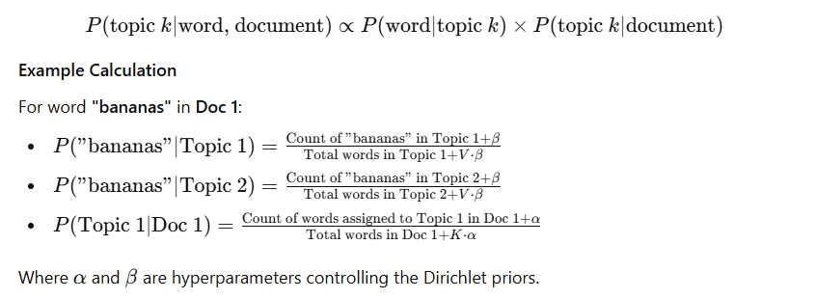

Step 4: Iterative Updates
Repeat the assignment and probability updates for a set number of iterations until convergence.
Output
The result will be two topics, with words distributed across them:
- Topic 1: [broccoli, bananas, eat, like, and, spinach, smoothie]
- Topic 2: [cherries, are, my, favorite, fruit]
This indicates that Topic 1 relates to food/recipes, and Topic 2 relates to favorite fruits.

Non-Negative Matrix Factorization (NMF) is a popular dimensionality reduction technique often used for topic modeling in Natural Language Processing (NLP).
It decomposes a term-document matrix into two smaller matrices: one representing the topics and the other representing the weights of those topics in the documents.
